***THE TRAGEDY OF FLIGHT : A COMPHRENSIVE CRASH ANALYSIS***

***DATA COLLECTION AND EXTACTION FROM DATABASE***

With this project are to see the collective data about the tragedies happening the field of aerial transportation and the past tragedies and accidents happened in the past.

***SPECIFICATION OF THE PROBLEM*** :

The cases of aircraft crashes are due to various reasons and some of them are:

* Pilot Error
* Weather
* Miscellaneous
* Maintenance of aircraft
* Miss monitoring the aircraft traffic

The major cause is due to the error of airport management and the pilots on duty.

***Business requirements***

A business requirement for a comprehensive crash analysis of The Tragedy of Flight would likely include the following elements:

● Detailed information about the crash, including the date, time, location, and weather conditions at the time of the incident.

● A thorough analysis of the events leading up to the crash, including any

mechanical failures or human errors that may have contributed to the

incident.

● A review of the flight data and cockpit voice recordings to gather additional

information about the events leading up to the crash.

● Interviews with the flight crew, passengers, and any witnesses to the crash to gather additional information about the incident.

***Literature Survey***

A literature survey is a method of researching existing literature and studies related to a specific topic. In the context of analysing the airplane crash, a literature survey would involve reviewing studies and articles that have been published on the topic of airplane crash, as well as studies specific to crash analysis. The literature survey would include sources such as academic journals, industry reports, and online articles. The literature survey would also explore any existing research on airplane crash, and would aim to identify any unique challenges or opportunities that to overcome crash.

***Social and Business Impact.***

Social Impact: The analysis can provide closure to the families and loved ones of the victims of the crash, as well as to the broader public. It can also help to improve

public confidence in the aviation industry by identifying and addressing any safety issues that may have contributed to the incident. Business Impact: The analysis can have significant business implications for the airline and aircraft manufacturer involved in the incident. If the analysis finds that the crash was caused by mechanical or design issues, the manufacturer may be liable for damages and may face significant financial losses. The airline may also face legal claims and reputational damage.

***Data Collection & Extraction from Database***

Data collection is the process of gathering and measuring information on variables of interest, in an

established systematic fashion that enables one to answer stated research questions, test hypotheses, and evaluate outcomes and generate insights from the data.

***COLLECTION OF DATASET:***

We have been collecting data from various sources and examples of collecting data from various sources.

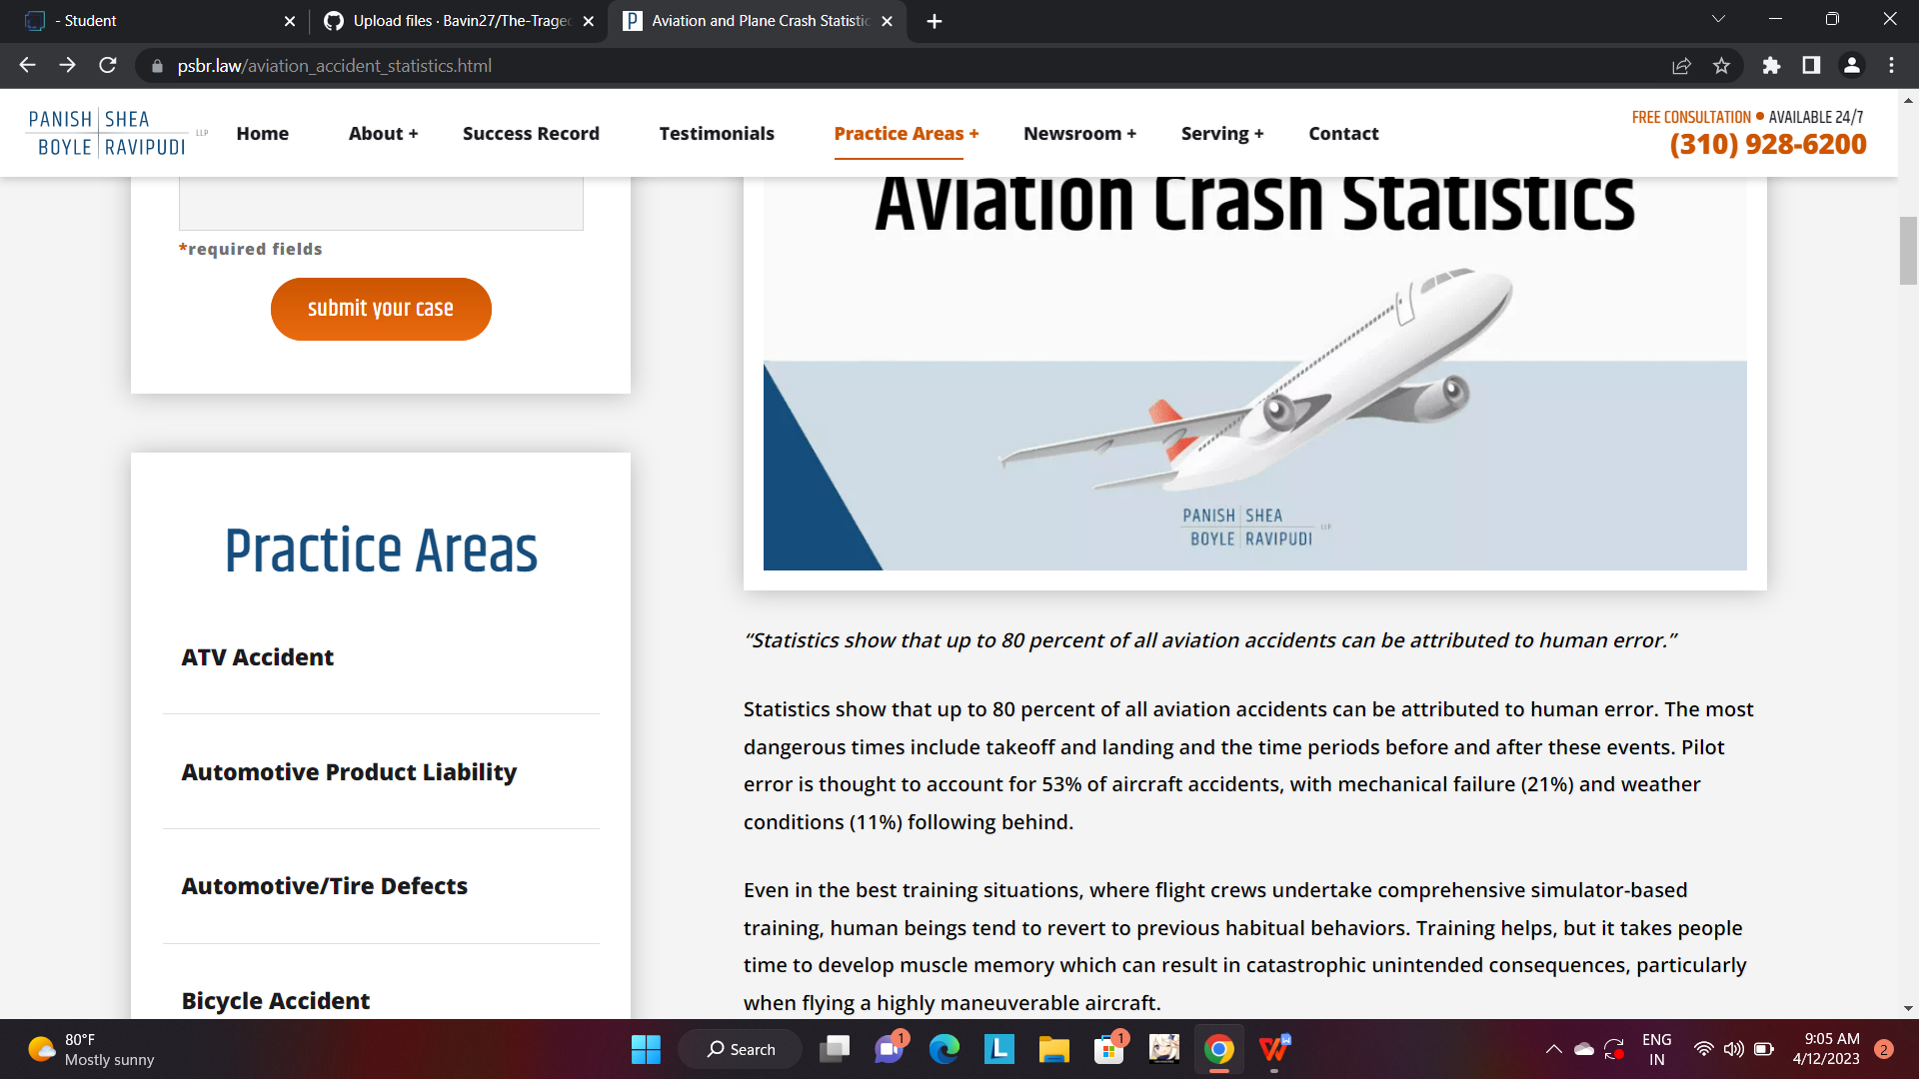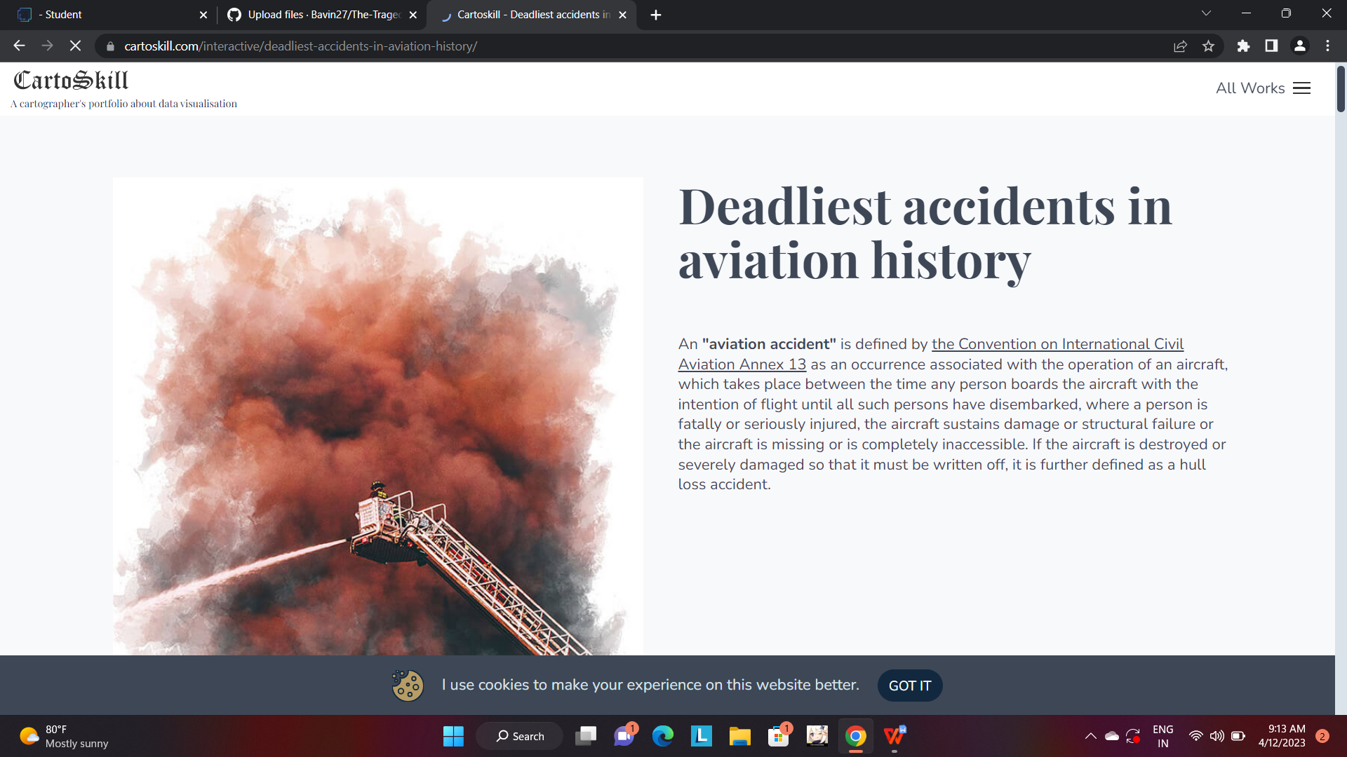

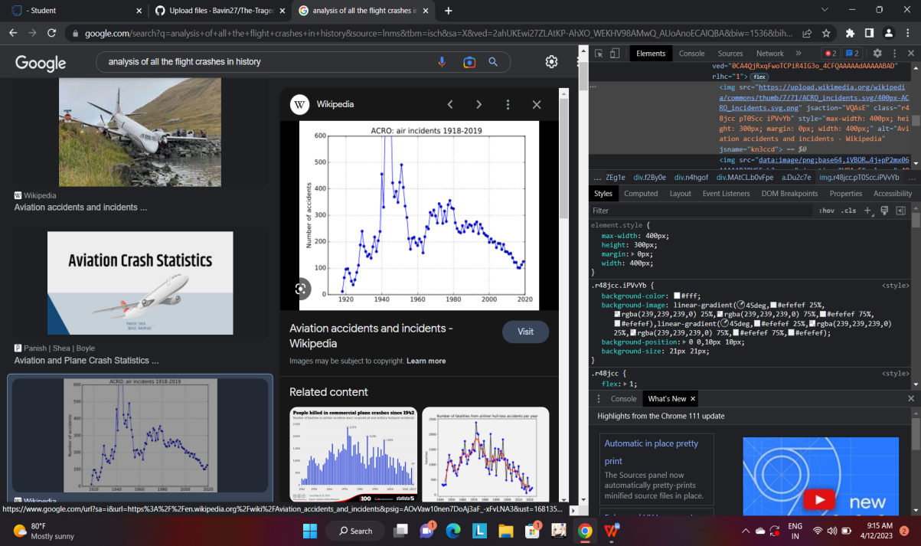

***Understand the data***

Data contains all the meta information regarding the columns described in the CSV

files. we have provided 8 CSV files:

1. Date 7. Fatalities

2. Location 8. Ground

3. Operators

4. Route

5. Type

6. Aboard

***Storing Data in DB & Perform SQL Operations***

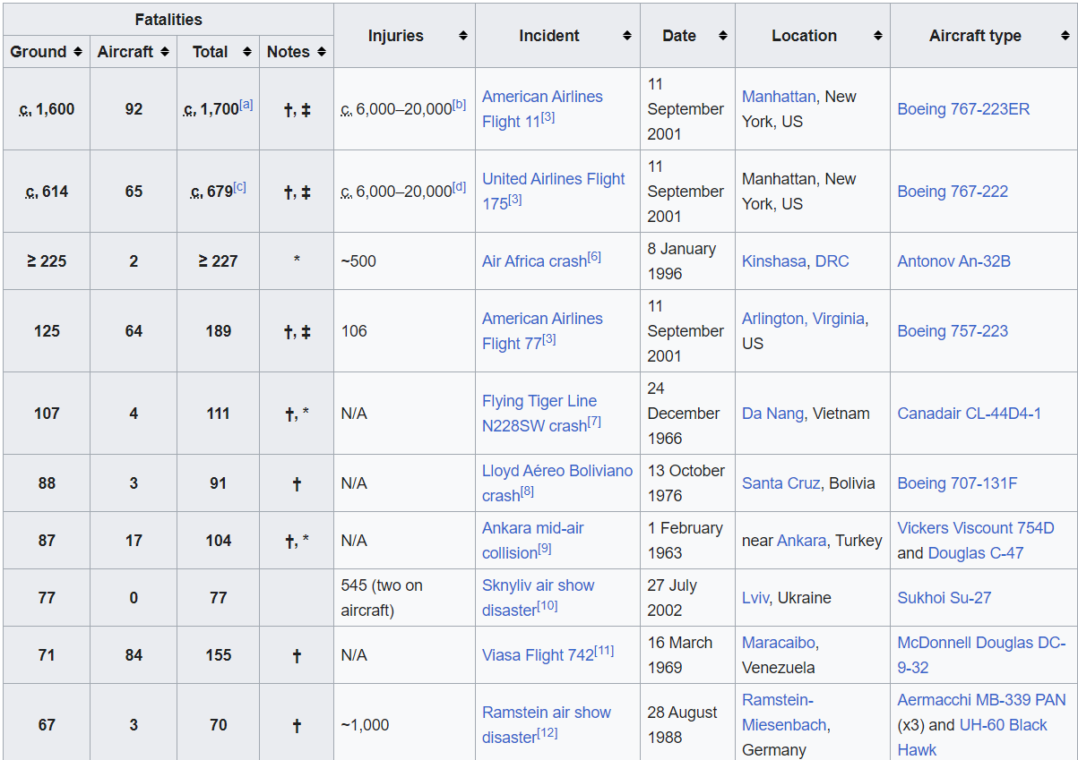

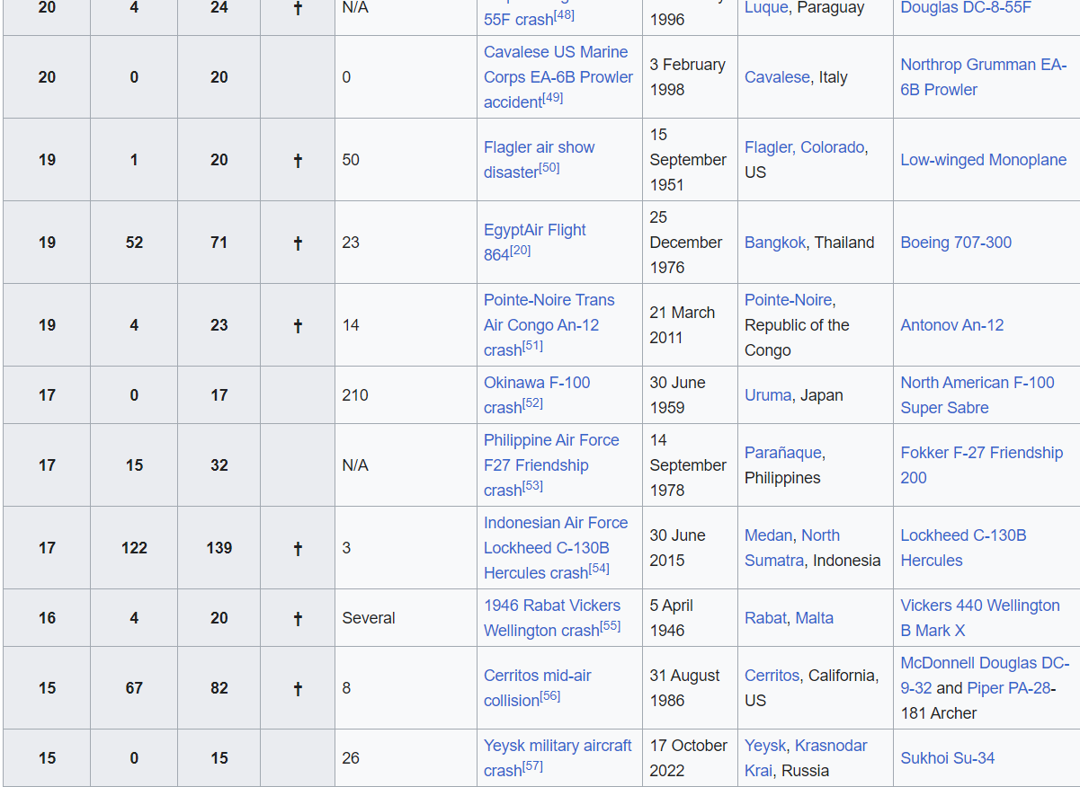

***CONNECT DB WITH TABLEAU:***

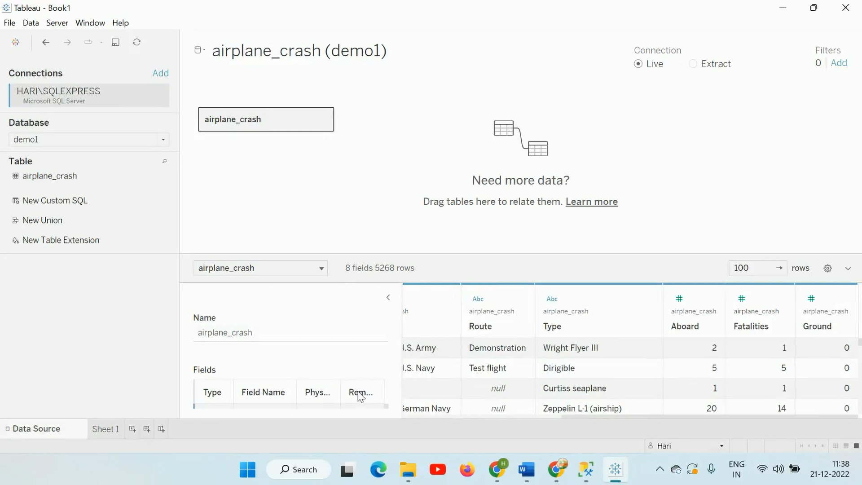

***Data Preparation***

***Prepare the Data for Visualization***

Preparing the data for visualization involves cleaning the data to remove irrelevant or missing data, transforming the data into a format that can be easily visualized, exploring the data to identify patterns and trends, filtering the data to focus on specific subsets of data, preparing.

the data for visualization software, and ensuring the data is accurate and complete. This process helps to make the data easily understandable and ready for creating visualizations to gain insights into the performance and efficiency.

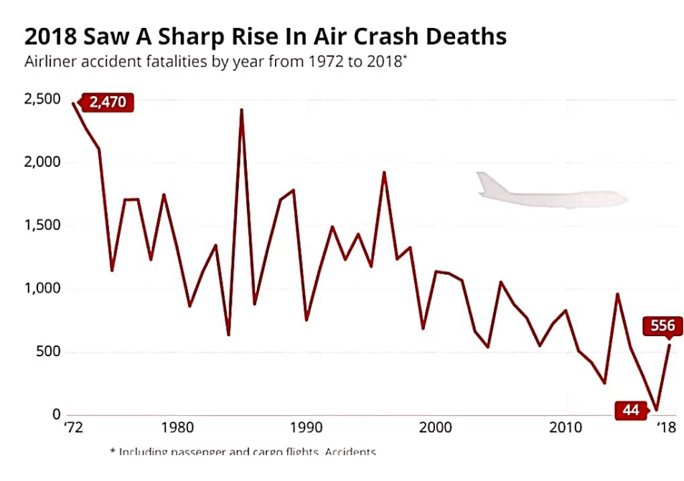

***DATA VISUALISATION***

***Comparing aboard fatalities vs ground***

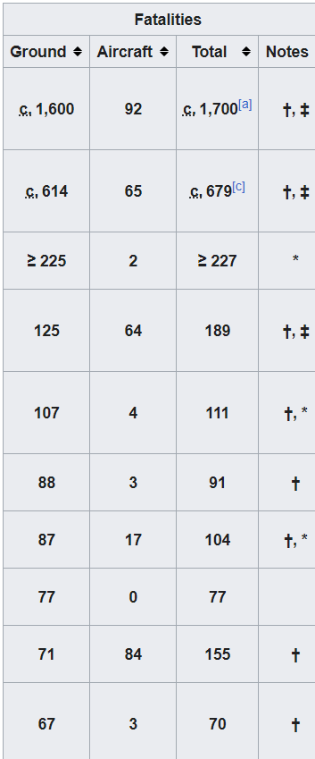

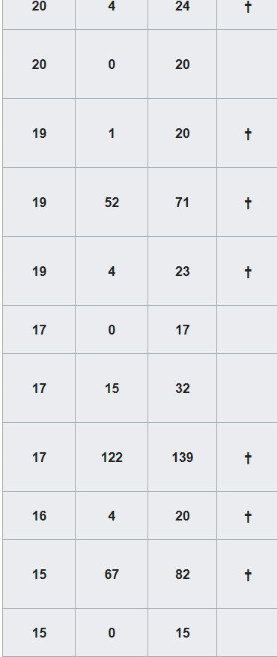

***MAX ACCIDENTS BASED ON YEARS***

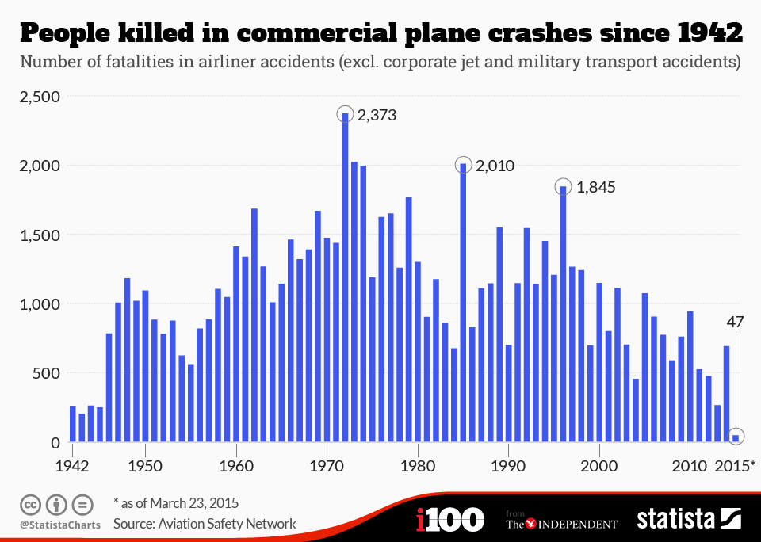

***Accidents happened in 1972 Based on Months:***

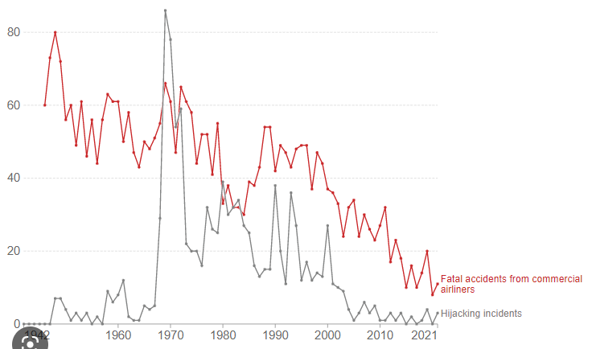

***Highest No. Of Accidents Happened by operators:***

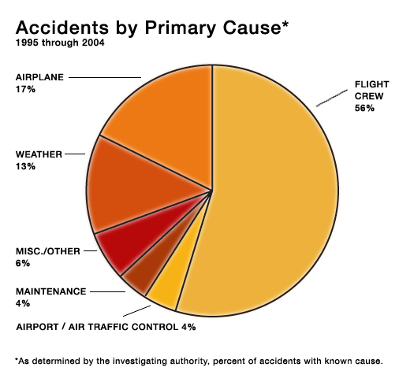

***Top 10 places where the most accidents happened:***

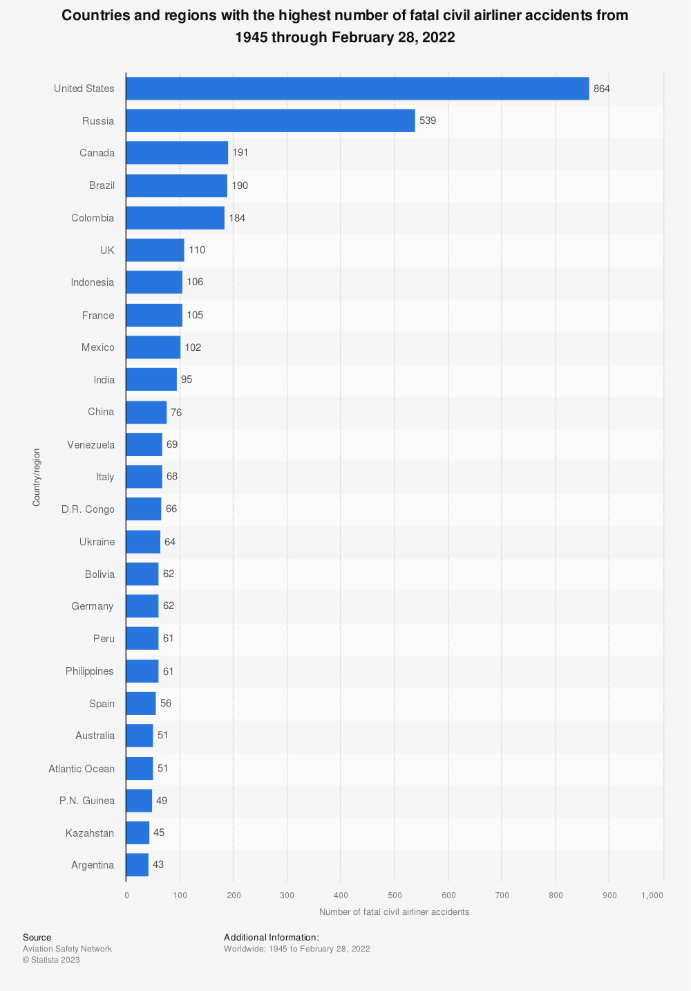

***Flights which had most accidents:***

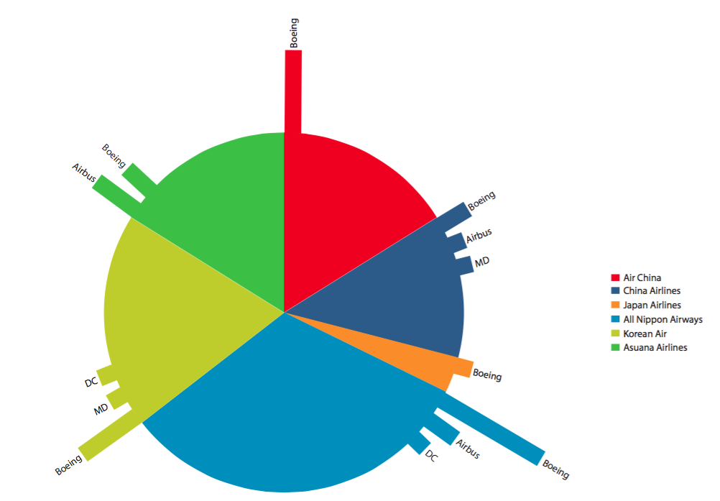

***Accidents Based on Region:***

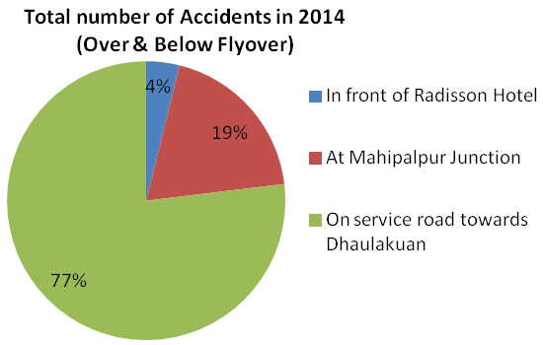

***Dashboard***

A dashboard is a graphical user interface (GUI) that displays information and data in an organized, easy-to-read format. Dashboards are often used to provide real-time monitoring and analysis of data, and are typically designed for a specific purpose or use case. Dashboards can be used in a variety of settings, such as business, finance, manufacturing, healthcare, and many other industries. They can be used to track key performance indicators (KPIs), monitor performance metrics, and display data in the form of charts, graphs, and tables.

***Responsive and Design of Dashboard***

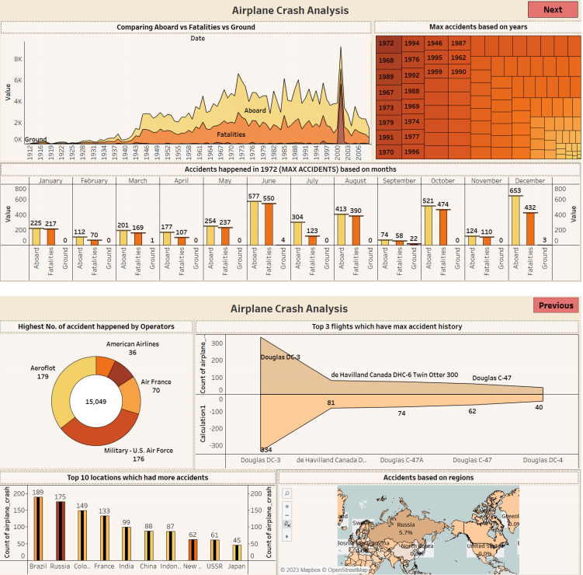

***STORY:***

The project we make engaging about “The Tragedy of Flight : A comprehensive crash analysis” .First of all we collect data from the articles available on the internet .

A series of fatal accidents on American schedule airlines in last month of 1959 and the first months of 1960 has provoked a searching re-examination of air safety practice by the airlines.

Current issues are now on the Chicago Journals website. Read the latest issue .Established in 1958, The Journal of Law and Economics publishes research on a broad range of topics including the economic analysis of regulation and the behaviour of regulated firms, the political economy of legislation and legislative processes, law and finance, corporate finance and governance, and industrial organization. The Journal has published some of the most influential and widely cited articles in these areas.

Use search engines: Google, Bing, and other search engines can be a great place to start when looking for articles on a specific topic. Try using keywords related to the tragic flight you're researching, such as the flight number, airline, date, location, and any other relevant details.

Check news websites: Major news outlets often cover tragic events like plane crashes, so checking their websites can be a good way to find articles. You can also try searching for articles on the websites of smaller, local news outlets.

Use academic databases: If you're looking for more in-depth articles, academic databases like JSTOR, EBSCO, and ProQuest can be helpful. These databases allow you to search for articles from scholarly journals and other academic publications.

Check library resources: Your local library may have resources that can help you find articles on your topic, such as access to academic databases, newspapers, and other publicat.